AGENDA

February 13, 2018

THE UNION COUNTY BOARD OF SUPERVISORS WILL MEET IN REGULAR SESSION, Tuesday February 13, 2018 AT
9:00 AM IN THE BOARD ROOM IN THE UNION COUNTY COURTHOUSE.

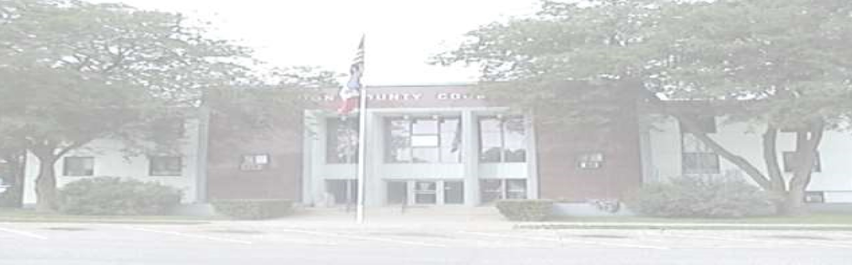

U
nion County Board o
f Supervisors

N. Pine Street Suite
10
300

Creston, Iowa 50801

Phone: 641
-
782
-

1720

Fax: 641
-
782
-
1709

Website: www.unioncountyiowa.org

Ron Riley
-

Chair

th St.
1345 190

Creston, IA 50801

641
-
782
-
0758

ronriley1977@gmail.com

Dale Cline

–

Vice Chair

th St.
1824 230

Creston, IA 50801

641
-
278
-
6858

clinedale13@gmail.com

Dennis Brown

th St.
2021 240

Shannon City, IA 50861

641
-
340
-
1098

djb1
@mchsi.com

9:00 AM Call the meeting to order; approve the agenda; approve the Minutes from the last meeting

9:05 AM Open Forum

9:10 AM Zach Gunsolley, Union County Engineer
- Maintenance Activity Report

10:00 AM Sandy Hysell, Union County Auditor
- Veteran’s Affairs Monthly Report
- Clerk’s Report
- Liquor License- Crestmoor Golf Club
- Budget Work Session

Claims

Adjournment

