UNION COUNTY

ORDINANCE NO. 53
AN ORDINANCE TO ESTABLISH A POLICY FOR THE CONSTRUCTION AND RECONSTRUCTION OF ROADWAYS AND BRIDGES ON THE UNION COUNTY SECONDARY ROAD SYSTEM.
BE IT ORDAINED BY THE BOARD OF SUPERVISORS OF UNION COUNTY:

SECTION 1 -- PURPOSE
The purpose of this ordinance is to establish Union County's policy for the construction of roads, reconstruction of roads, construction of bridges, reconstruction of bridges and other roadway and drainage features associated with road and bridge construction.

SECTION 2 LEVEL OF SERVICE
The level of service shall be based on traffic counts, pavement type, roadway geometrics and other data used in accepted engineering design as established by the County Engineer, Iowa Department of Transportation and the Federal Highway Administration.

SECTION 3 - DESIGN CRITERIA
In implementation, this policy shall set the minimum design standards that Union County will follow in the construction or reconstruction of roads and bridges. These criteria shall be based on accepted engineering practices and standards established by the Iowa Department of Transportation and the Federal Highway Administration.
The County Engineer shall assure the minimum design standards established herein are adhered to in a uniform manner unless, in his or her professional judgment, a deviation from standards is warranted. Minimum design standards are not subject to discretionary enforcement. Any deviations must be documented as unreasonable and or impossible to implement by the County Engineer and/or the County Board of Supervisors.

PAVED ROUTES

A)New Pavement
- New pavement shall be constructed 22' wide and include granular shoulders.
- Paved shoulders and edge line rumble stripes shall be constructed if crash data warrants based on accepted HSIP and TSIP cost/benefit analysis.
- Concrete rumble strips shall be installed on all approach stop situations.

UNPAVED ROADS
A) Gravel Roads
1) New construction or reconstruction of a gravel road shall be in accordance with the following design standards unless FM or Federal funding is involved.
ROADWAY DESIGN ELEMENTS
Design Volume (ADT | Over 400 | 250-400 | 50-250 | Under 50
Design Speed (mph)  Stopping Sight Distance  Minimum Radius (ft.)  Maximum Gradient (%)  Traveled Way (ft.)  Shoulder Width (ft.)  Roadway Top Width (ft.)  New Bridge Roadway Width (ft.)  Restored Bridge Roadway Width (ft.)  Foreslope (ratio)  Minimum Ditch Depth (ft.) (1)  Minimum Ditch Bottom Width (ft.) (1)  Minimum Fill Height (ft.) (2)  Minimum Right-of-Way Width (ft.)  Surfacin Thickness (IDOT Class D Roadstone | 45  360  500  9  22  6  30  24  3  8  3  80 | 40  360  500  9  22  4  30  30  24  2.5:1  3  5  3  66 | 40  305  465  10  20  3  26  24  20  2.5:1 2  2  66 | 35  250  350  10  20  2 24  24  20  2  2  66
 | 2.0 Inches
CULVERT DESIGN ELEMENTS
Roadway Culvert Design Discharge  Entrance Culvert Design Discharge  Culvert Pipe Minimum Cover (ft.)  Roadway Culvert Minimum Diameter (inches)  Entrance Culvert Minimum Diameter inches) | 50 Year Flood Frequency 10 Year Flood Frequency  2.0  24  18
These standards are based on the Iowa Dept. of Transportation's Instructional Memorandums to County Engineers with modifications.
Notes:
- At locations that require a ditch for drainage or snow storage such as in cut sections.
- Road top height measured at shoulder above surrounding ground to minimize snow drifting and to promote drainage in fill sections.
B) Level B and C Maintenance Roads
1) Level B and C roads shall be constructed to the minimums as contained in the Code of Iowa.

B)Reconstruction of Pavement
- Paved roads shall be reconstructed with a 22' wide pavement or to the previous pavement width, whichever is greater and granular shoulders shall be included.
- Concrete rumble strips shall be installed on all approach stop situations.

BRIDGES & Drainage Structures
- Paved Routes
  - Bridges on paved routes shall be built with a minimum width of 30'. Wider structures will be installed when there are issues relating to oversized vehicles, pedestrian facilities, biking usage or other issues where the additional width is felt to be warranted.
  - Culverts under paved roads shall be concrete or corrugated aluminum.
  - Pipe culverts larger than 54" in diameter may be substituted with reinforced box culverts.
  - Design for drainage structures will be governed by accepted hydraulic design standards. Input from IDNR, Corp of Engineers, Iowa DOT, NRCS, or USGS may impact the size and type of the structure to be placed.
  - Water and livestock will use separate structures whenever possible.
- Unpaved Routes
  - Bridges will normally be a minimum of 24' on gravel roads. Bridges on dead end roads may be narrower at the discretion of the County Engineer
Culverts may be metal or concrete. Pipe culverts larger than 54" in diameter may be substituted with reinforced box culverts.
  - Design for drainage structures will be governed by accepted hydraulic design standards. Input from IDNR, Corp of Engineers, Iowa DOT, NRCS, or USGS may impact the size and type of the structure to be placed.
  - Water and livestock will use separate structures whenever possible.

C) Class B & C Roads
Class B and C roads will be built to the minimums as outlined by Iowa Code.
D) Entrance Bridges
Any and all bridges/drainage structures that are fully or partially in the road right-of-way that serve as entrances to private property from the public roadway shall be considered the jurisdiction and responsibility of the County. If a structure does not sit fully or partially in the road right-of-way it will be considered a private structure and not under the jurisdiction of the county.

SECTION 4 REPEALER
All ordinances and resolutions, or parts thereof, in conflict herewith are hereby repealed.

SECTION 5 SEVERABILITY CLAUSE
If any section, provision, or part of this ordinance shall be adjudged invalid or unconstitutional, such adjudication shall not affect the validity of the ordinance as a whole or any section, provision, or part thereof not adjudged invalid or unconstitutional.

SECTION 6 WHEN EFFECTIVE
This ordinance shall be in effect immediately after its final passage and publication as provided by law. In addition, this ordinance shall remain in effect until such time the Board of Supervisors passes a future ordinance repealing this ordinance.
Passed and approved this 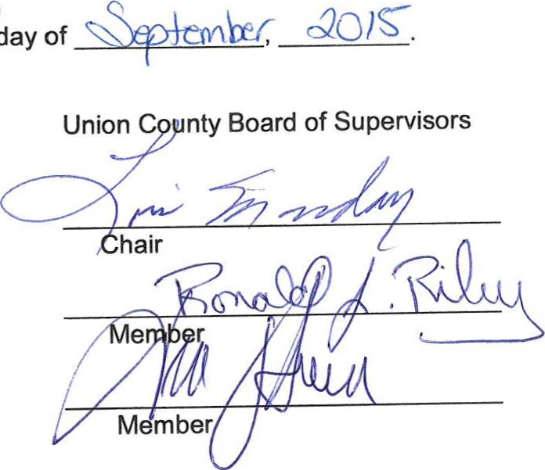
day
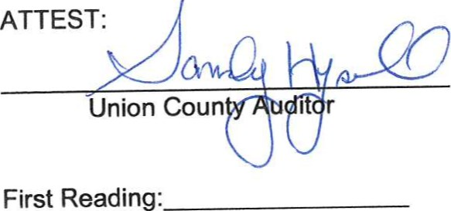
First
Second Reading: 9. og,aolS
Approved:
Published:

NOTICE OF PUBLIC HEARING UNION COUNTY, IOWA
TO WHOM IT MAY CONCERN:
WHEREAS, Union County constructs new roads and bridges and reconstructs certain roads and bridges due to damages caused by natural disasters or to improve service characteristics, and
WHEREAS, there is a need for criteria or minimum design standards that will be followed when constructing or reconstructing roadways and bridges,
NOW THEREFORE BE IT RESOLVED, that a hearing involving the second reading of the ordinance to establish a policy for the construction and reconstruction of roadways and bridges on the Union County Secondary Road System will be held in the Board Room, at the Union County Courthouse, Creston, Iowa at 10:00 AM, Central Daylight Savings Time, on Monday, September 28, 2015 in accordance with the Code of Iowa, chapter 331.
